For LEASE

444411
EEaasstt
AAvveennuuee

14607
Rochester, NY

For Lease - 21,658 +/-SF Multi-Tenant Office Building on
1.7 Acres.

The building is located at the corner of East Avenue and Sibley Place, one of the premier locations in the City of Rochester. A prominent corner location on one of Rochester’s most desirable avenues.

Located in the vibrant East End District of Rochester. In close proximity to the Central Business District/Downtown Rochester.

Nearby amenities include: The Little Theatre, Genesee Valley Club, Strathallan Hotel, Lyric Theatre, RMSC, The Inn on Broadway, Eastman Theatre, Memorial Art Gallery, Strasenburgh Planetarium, and George Eastman Museum.

Current build-out includes: multiple private offices, a conference room, kitchens, copy room, waiting area, cubicles, storage area, serviced by an elevator.

Existing building is ideal for a single tenant or multiple tenants. Flexible floor plans available. The building
can be subdivided down to 5,000 sf. 80 parking spaces.

R3-High Density Residential, Overlay-office, East Avenue Preservation District

441 East Ave

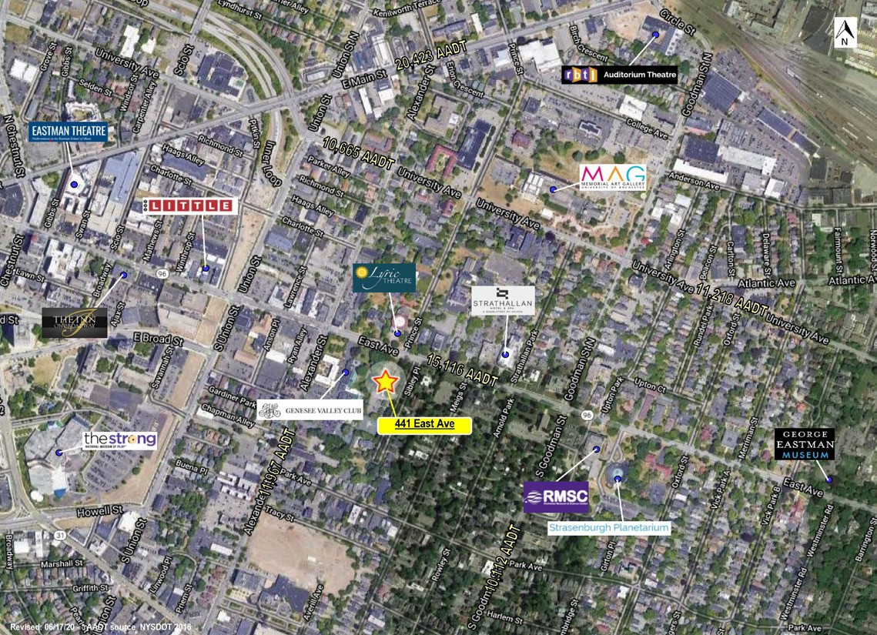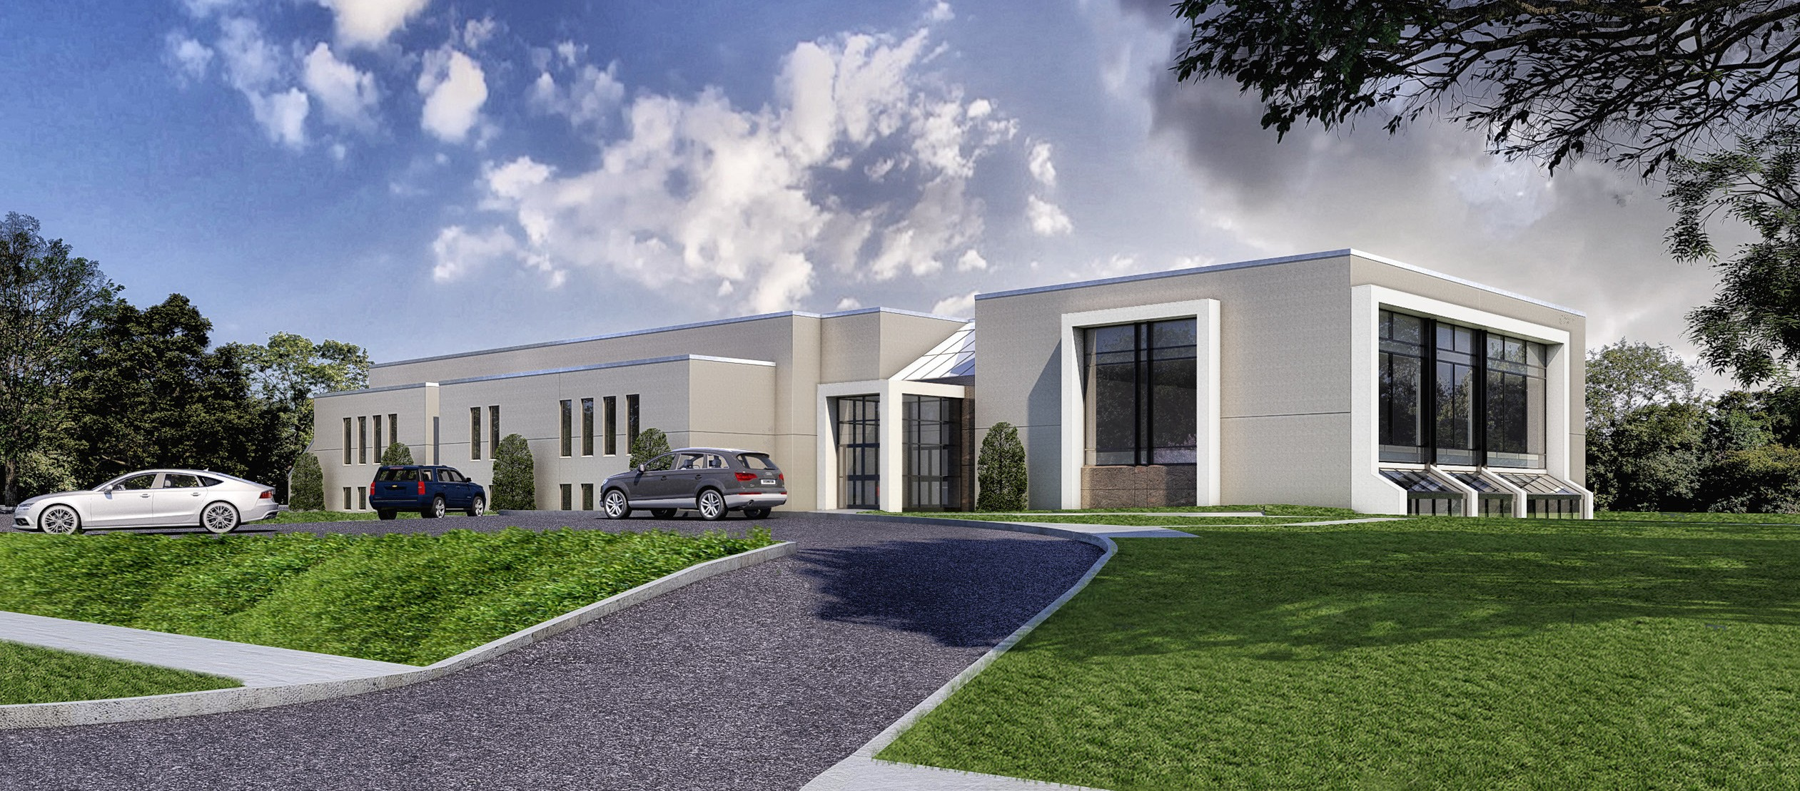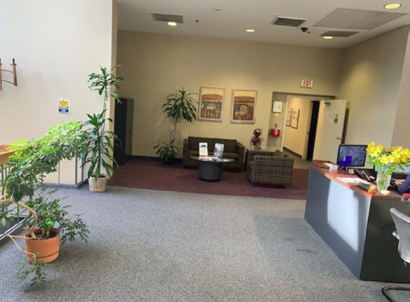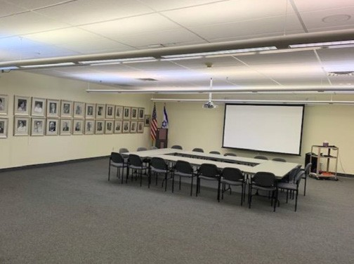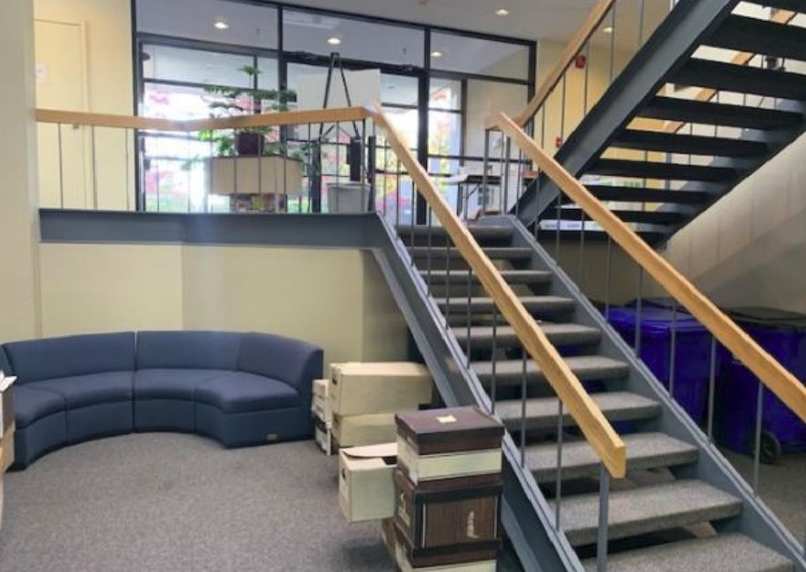

WWW.LLDENTERPRISES.COM

For LEASE

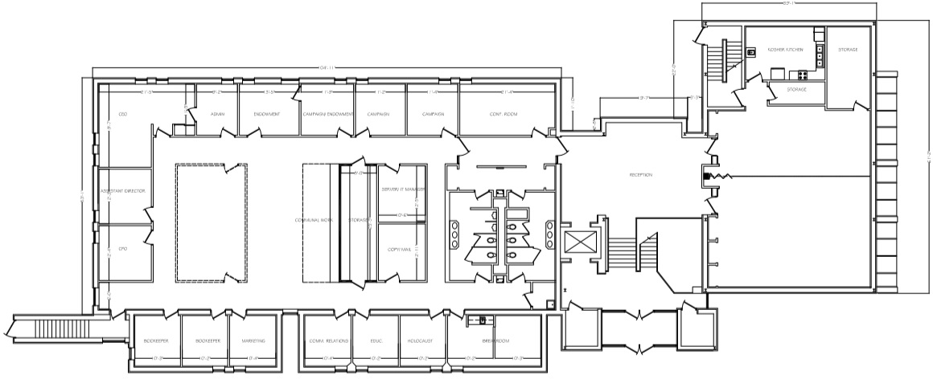
UPPER LEVEL Floor Plan

415 Park Avenue - Rochester, NY 14607
Michael A. Smith - Michael@LLDEnterprises.com
Director of Leasing / Licensed Real Estate Salesperson

585-244-3575 ext. 310

David M. Dworkin - David@LLDEnterprises.com
Licensed Real Estate Broker

585-244-3575 ext. 301

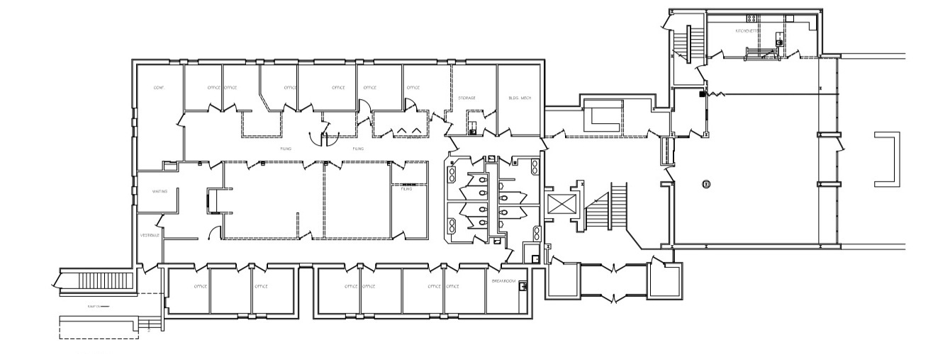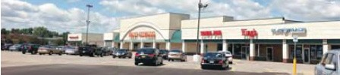WWW.LLDENTERPRISES.COM
oor Plan
LOWER LEVEL Fl
Rochester, NY 14607
444411 EEaasstt AAvveennuuee

06/18/20

